Instructions follow on how to replace the HD of your Mark IV with an SSD and enlarge the music partition. These instructions come with no warranty!

Hardware needed for the piano, available from Amazon, total cost under $200:

- Corsair SSD Mounting Bracket Kit 2.5" to 3.5" drive bay (CSSD­BRKT1)
- HDE SATA to PATA/IDE Hard Drive Interface Adapter (this was the interface we used, but in hindsight, it was not ideal. We could only connect two screws. Since the SSD was light this was not a big problem, and it does not vibrate.)
- SSD such as Samsung 850 Pro 256GB 2.5­Inch SATA III Internal SSD (MZ­7KE256BW)

Hardware needed to attach the SSD and Disklavier hard drive to your PC to do the cloning and partition enlargement, from Amazon, each item about $20:

- iDsonix® SuperSpeed USB 3.0/2.0 to SATA Hard Drive Docking Station For 2.5 or 3.5in HDD/SSD Tool Free Design - Supports 4TB+ Hard Drives Premium 12V2.5A Power Adapter&3.3 Ft USB3.0 Cable included
- Cables Unlimited USB-2110 USB 2.0 to IDE and SATA Adapter Cable with Power. (You may want to look for alternatives to this unit. Some on Amazon recommended the Bytek and the Vantec units as higher quality. Our conclusion: you should test what you buy on a non critical disk to be sure it is working correctly. )
- Powered USB Backup Drive for Disklavier.

A way to store your old Disklavier hard drive: Search for “electrostatic clamshell for hard drive” if you don’t have an electrostatic bag.

Linux software for cloning and repartitioning:

- You need Clonezilla and Gparted. Clonezilla clones disks and gparted resizes partitions.

- We used Clonezilla from Parted Magic (which cost <$10 to download). We tried to use the free version ISO from Clonezilla Live, but it did not boot for us.

- However, we had trouble with the version of gparted in Parted Magic and DO NOT recommend it. Download gparted from Gparted Live: http://gparted.org/download.php

- Any Linux ISO image can be converted to a bootable USB using the free unetbootin, which runs on Mac, Linux, or Windows.

Access to a Windows PC or a machine that runs Linux . We found running the Linux programs on a Mac using USB drives impossible. It may be possible through Parallels. But if you can borrow a friend’s PC, that is an easy way to go.

Instructions
- Using the Disklavier utility, backup your Disklavier to a USB fat32 formatted HD. It took 11 hours 51 min. for us to get a backup—but in case something goes wrong this backup will be your fallback for restoring your music.
- Shutdown the Disklavier, and for safety, unplug it.
- Remove the I/O center from the Disklavier, and remove the hard drive. Hook the hard drive up to the Cables unlimited adapter cable. Ours did not come with instructions, so we found a YouTube video that was somewhat helpful: https://www.youtube.com/watch?v=N-oi_082CeU.
- Hook up your computer (we used a 12 year old HP Pavilion laptop with 3 USB ports and a CD/DVD drive) to the Disklavier hard drive and the SSD. Basically, you need to have a way to boot from a CD or USB, plus two additional USB connections for the Disklavier hard drive and the SSD hooked up to the Hard Drive Docking Station.
- Boot using Clonezilla. (on our PC we hold down the escape key to boot on a CD, and use F10 to change the booting order if booting from a USB, but each computer may be different)
- Clone the Disklavier disk. http://clonezilla.org/show-live-doc-content.php?topic=clonezilla-live/doc/03_Disk_to_disk_clone BE VERY CAREFUL to choose the right source and target disk!!! The easiest way is to tell which disk is which is by size. We used the expert mode, but never changed anything, so the novice mode would have probably worked fine. It took us about 3 hours to make the clone, using USB 2. (A later restore was done in 30 minutes, so this time may be excessive.) You do want to keep the partition sizes the way they are.
- Shut down the PC.
- Remove the Disklavier disk from the computer and store it for long term safety.
- Reboot using the gparted stand-alone disk. Start gparted.
- First you must choose the right disk – refer to the screen shot below. The arrow points to a disk list drop down. You are looking for one with the size of your new SSD. Select the disk.
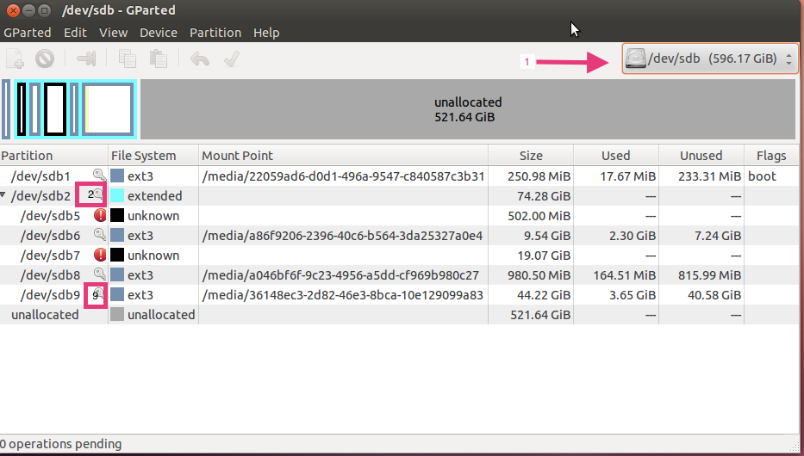
- It should look something like the screen shot, except your Used amounts will be different, and the three letters after the /dev/ may be different. But the numbers, 1,2,5,6,7,8,9 should be the same. For example, where we have sdb, you may have sdc.
- You will notice the “key” icons next to the partitions. They indicate that the partitions need to be unmounted before resizing. You only have to unmount partitions numbered 7,8,9, and 2. For each, you select the partition then choose Partition/ Unmount. Gparted then refreshes the partition list, which seems to take an excessive amount of time, like about 30 seconds. You then repeat for each of the partitions 7,8,9, and 2.
- You are now ready to enlarge two partitions, the one ending in 2 and the one ending in 9. Select the partition ending in 2 first, then select Partition → Resize/Move. You will be presented a graphical display and a form. We had better luck using the graphical display.
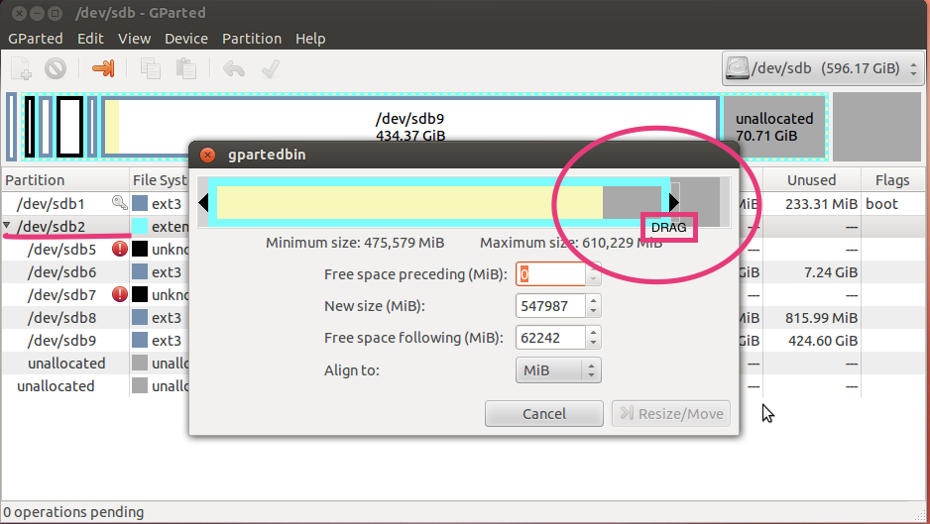
Just drag the arrow out to nearly fill the box. When you have changed the size, the Resize/Move button will become active. Press it. You are not done yet: you must APPLY the change. (You should see “1 operation pending”). You will see a Red revert button and a green apply button. Choose the green apply button.
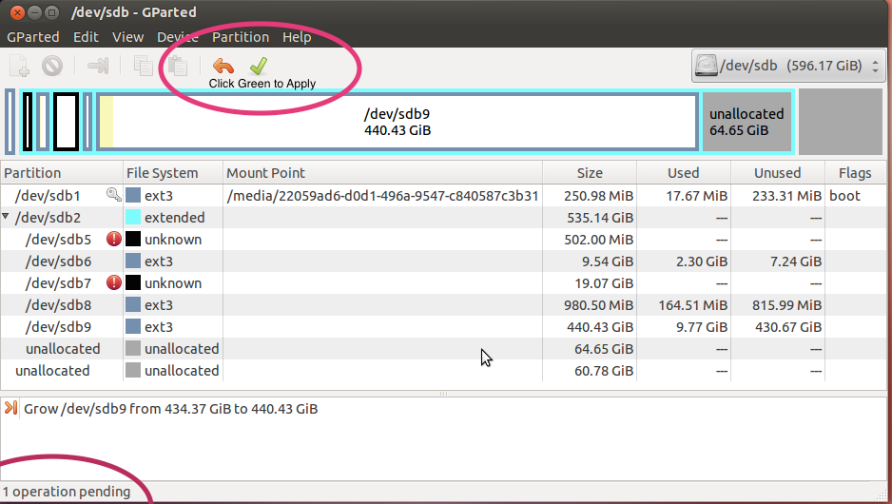
Now, repeat the process for partition 9, which is where your songs are stored. Increase its size to near the max also, and apply. You have now enlarged your SSD to hold more songs. You are ready to install the new SSD.

We brought in a Yamaha Certified technician to remove the I/O center and hard drive and to install the SSD. If you are comfortable dealing with circuit boards and hard drives, you can do it yourself as it is not difficult. Plug the SSD into the IDE to SATA interface; connect up the IDE and power cables to the interface; install the combined SSD and IDE to SATA adapter into the mounting bracket, and finally attach the mounting bracket with the provided screws on to the slot in the I/O board vacated by the removed internal HD. Replace the entire I/O top assembly (with SSD installed) on the I/O Center from which it was removed. Reinstall the I/O Center beneath the Disklavier, reconnect all cables to the I/O Center that were disconnected when it was removed, plug in and power on the Mark IV, and allow 15-25 minutes while the Mark IV reboots from the new SSD. The Disklavier will go into Standby when the bootup is completed.

The install of the SSD/IDE to SATA interface/SSD bracket into the slot on the top of the I/O Center vacated by the internal HD is somewhat difficult. Because the IDE to SATA interface protruded about 1/8 in. beyond the width of the SSD mounting bracket, we were not able to position it fully within the bracket and use all four mounting screws for mounting. We were able to mount it with two of the mounting screws on one side and this seems perfectly adequate since the SSD is light and has no moving parts. If someone finds an IDE to SATA interface that fits this bracket better, please post on the DUG.

